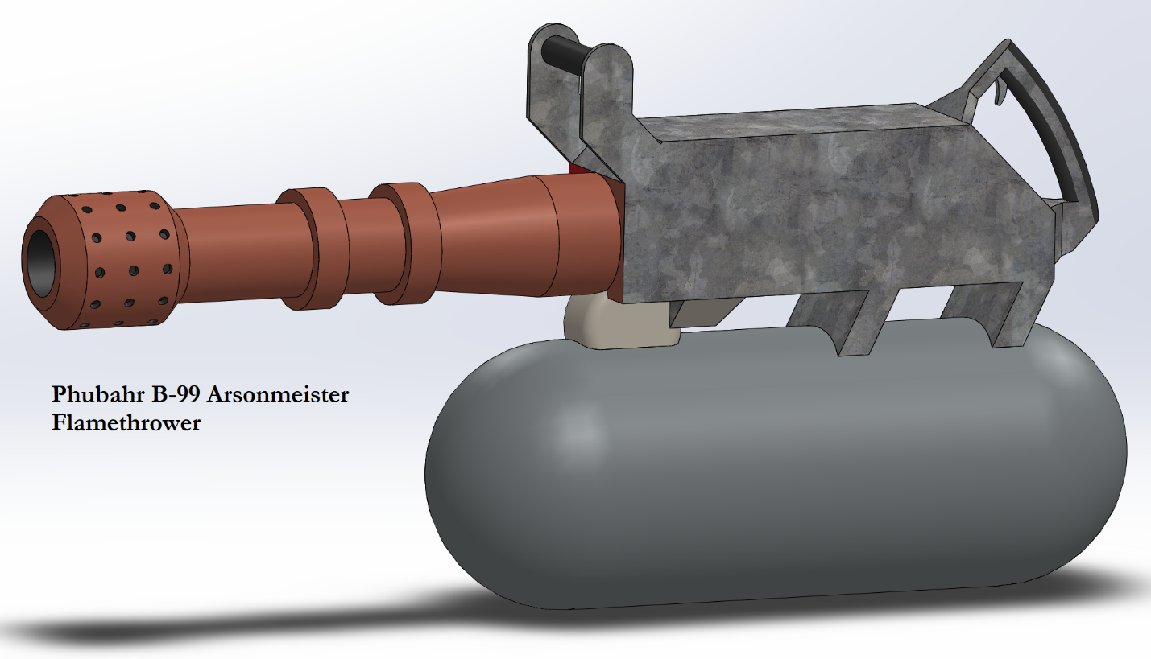

Phubahr B-99 ‘Arsonmeister’ Flamethrower (Heavy Weapon)
Reload: 1-2 Grips: 2 Cost: S4 Illegal
Ammo & Damage: Special 3d6
Qualities & Notes: Failure Prone, Scattergun, Short Range, Self-Supplying Ammunition
Special: Any sophonts within grenade blast radius of the primary target are included in the attack, but if hit only suffer 1d6 damage, and none if missed. Any target that takes damage from this weapon, including from the Scattergun or Failure Prone qualities, is considered to have been hit with the Burners ammunition.

Phubahr certainly knew their audience when they named this weapon ‘Arsonmeister’. This weapon is a fiery explosion waiting to happen, which is terrifying to some and very, very enticing to others. Phubahr claims their special valve system ensures that the flames can’t possibly back-burn into the fuel tank, but several smoking craters where previous buyers were standing would indicate that they haven’t quite perfected this device.
The Arsonmeister’s huge underslung fuel tank is filled with Phubahr’s ‘Liquid Blaze’ proprietary incendiary fluid, which behaves almost exactly like solvated Burnex gel, although they deny any accusations of corporate espionage. The tank is highly pressurized, containing a frankly horrifying quantity of the hyper-flammable goo, and while it is armored and reinforced, an unfortunately placed enemy shot can still turn the wielder into a truly awe-inspiring firework show. When it does work properly, the range is rather limited, as even the high-powered turbopump that launches the blazing liquid can’t get the plume to reach targets more than about 50 meters distant.
Expensive by Phubahr standards, hazardous to everything within range both friendly and enemy, and somewhat unwieldy, the Arsonmeister manages to be worse than even an ion gun in nearly every category. For this reason, those who love ion guns and wear napalm-scented cologne absolutely love this weapon. If you want to be silhouetted against a raging inferno of your own making, having lit the pyre of all who displeased you, stay very far away from us, and head on down to a Planet Mercenary outlet to get yourself a Phubahr Arsonmeister.

