Doblitz Foundry Battlesnake Corvette
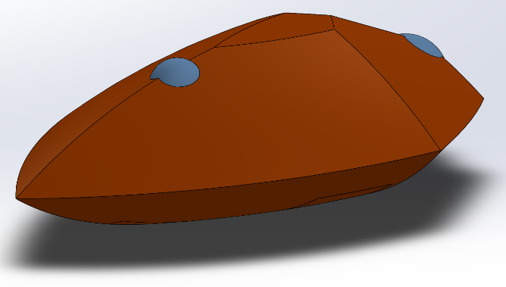
Cost: R14 (R15 with ‘luxury upgrades’)
Passengers: 80 long-term
AI Rating: 4 Class: X7 Hull Points: 16
Defense: 10, +5 shielded DR: 4
Damage: 3d6 anti-personnel, 1 hull anti-vehicle,
4d6 STS beam, 2d6 STS missile
Pre-installed systems: 2 Milspec annie plants,
Heavy anti-personnel weapons, light anti-vehicle
weapons, medium armor, Milspec ship locker,
light shield, medium STS beam, light STS missile,
basic teraport, Civilian fabber*
‘Luxury Upgrades’: Fabber is full Milspec, but
limited in size (5 meter cube), and sally port
installed
Compatible upgrades: Point-defenses, VDA,
weapon shield and armor upgrades, TAD,
additional annie plants, sally port

The Battlesnake Corvette was an experimental design by Doblitz, one which was only a mild success, and therefore is produced only in small runs. Like all Doblitz ships, it can take an impressive pounding without seeming to even notice, and was deliberately marketed for its survivability, downplaying its impressive equipment list. Indeed, only the ship-savvy and those who’ve owned or fought a Battlesnake know just how many tricks and how much firepower is tucked away in recessed ports in these ships.
The Battlesnake was designed to be one part versatile, one part reliable, and three parts survivable. It has decent firepower right off the assembly line, but an upgraded one can be incredibly potent for its size, while still maintaining a ‘durable but non-threatening’ visual aesthetic. For this reason, those mercenaries who have heard of this relatively obscure Doblitz design eagerly seek them out.
Marketed to less affluent planetary militaries as an all-around ship, the Battlesnake is capable of serving as a customs enforcer, policing and military craft, and a general utility ship. Unfortunately for Doblitz, very few governments bought any, and the design would have been dropped completely if not for the enthusiastic interest from private military groups, for whom the Battlesnake is just the right blend of tough, versatile, and powerful.
Battlesnakes are big for X-class ships, measuring 95 meters long, and quite broad and tall. Much of this bulk comes from the combination of thick armor, high ceilings on its four decks (which make it popular with large sophonts), the cargo bay amidships (which is often converted into a small vehicle deployment bay), and the large fabber. The fabber is rated Civilian, but only by a technicality and some code restrictions, with a 5-meter cube internal volume.
If buyers purchase the so-called luxury upgrades, the fabber is unlocked to full Milspec capability, aside from the size limitation, and sally ports are installed on either side of the cargo bay, allowing it to serve as a tiny launch bay. The bay is only 6 by 12 meters, but runs the full horizontal width of the ship. It can only fit a single smallish Y-class ship or up to four Z-class craft, but not both at once.
